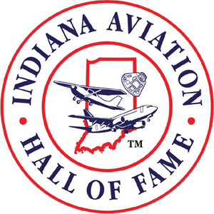
FOR IMMEDIATE RELEASE
CARMEL, IN, April 30, 2021 – The Board of Directors of the Indiana Aviation Hall of Fame are pleased to announce the Members of the Class of 2021. These outstanding individuals have made significant and enduring contributions to the history of aviation and aerospace in Indiana, the nation, or the world through achievement, leadership, exceptional service, innovation, or entrepreneurial spirit.
The 2021 Indiana Aviation Hall of Fame Honorees are:
- J. George Mikelsons, pilot, Founder and Chairman of ATA Airlines
- Clarence Cornish, military veteran, air racer, aerobatic pilot, oldest active pilot 1997-2003
- Daniel Orcutt, Director and visionary developer of the Indianapolis International Airport
- R.M. “Mitch” Grundman, educator, flight instructor, Purdue professor, FAA Examiner
- Charles DeBow, Jr., pioneering Tuskegee airman, WWII combat veteran, educator
- Margaret Ringenberg, WWII veteran Women Airforce Service Pilot, air racer, flight instructor
- Charles Holleman, educator, Purdue professor, Chairman of the Professional Pilot Program
- Gordon Graham, pilot, broadcaster, and promoter of general aviation in Indiana
These Honorees will be inducted at the Hall of Fame Honors Banquet on October 1, 2021, in Carmel, Indiana. Their induction and membership will be commemorated with a permanent Hall of Fame display plaque along with a personal medallion and award.
Information about the Indiana Aviation Hall of Fame, the Honors Banquet, and the INAHOF Legacy Members can be found at https://inahof.org.
————————————————====————————————————
The Indiana Aviation Hall of Fame, Inc., is a 501(c)(3) non-profit charitable organization

