Senator John McCain and Jim Graham
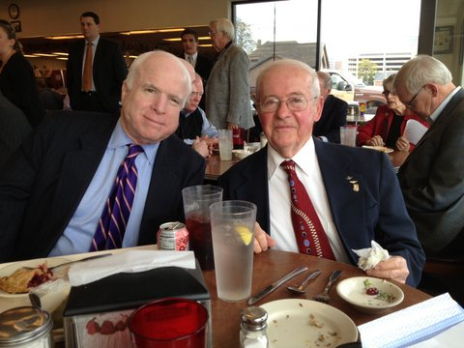

Brigadier General Charles McGee and Roberta Graham

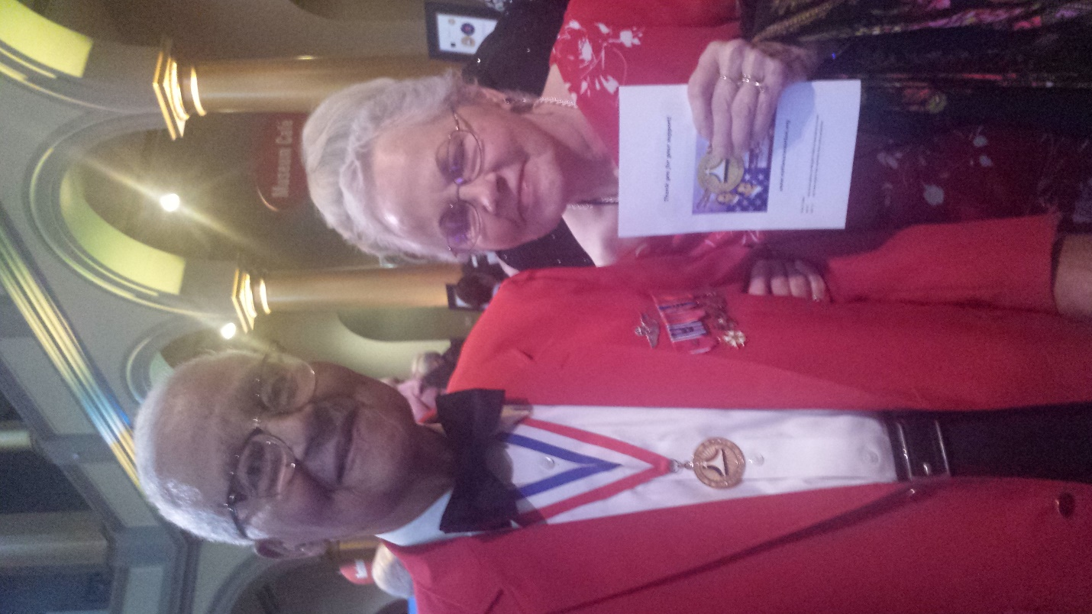

Charles was a speaker at one of our meetings several years ago. He is
100 years old now and was promoted to Brigadier General at Trumps state of
the union address recently. With Roberta at his induction into the Aviation Hall of Fame. He has more combat missions than any other Tuskegee airmen.

Jim Graham

This gentleman lived with us for a short while and protected Roberta's
oldest brother on B24 missions out of Foggia , Italy. The brother went down
in a thunderstorm on a mission and was lost in the Adriatic Sea. We most
recently visited Charles on the induction into the Aviation Hall of Fame
ceremony and have picture with Roberta with this note. See above in the 3
MB clip

Jim Graham

At State of the Union, a general's star for a Tuskegee Airman - and a
glimpse at the future

Stephen Losey

5 Feb 2020

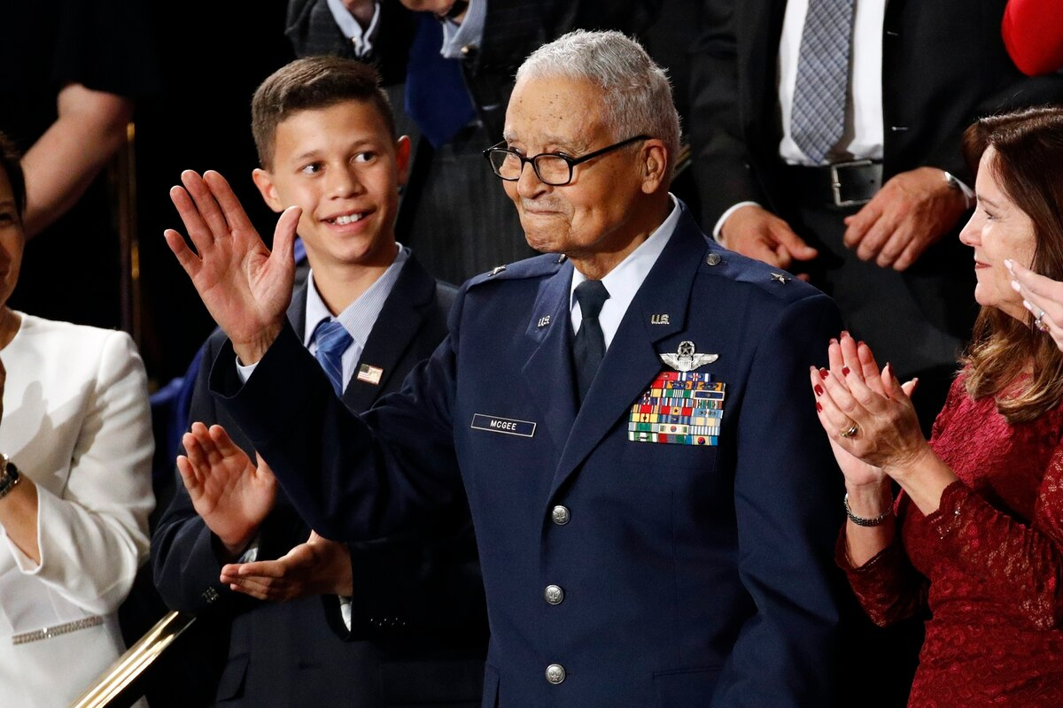

Tuskegee Airman Charles McGee, 100, and his great grandson Iain Lanphier
react as President Donald Trump delivers his State of the Union address to a
joint session of Congress on Capitol Hill in Washington, Tuesday, Feb. 4,
2020. (Patrick Semansky/AP) see attached photo

Charles McGee, a legendary aviator and one of the last surviving Tuskegee
Airmen from World War II, was officially promoted to brigadier general on
Tuesday, President Trump said at his State of the Union address.

Trump pinned the stars on McGee's shoulders in the Oval Office earlier that
day, and said he signed a bill promoting him a few weeks ago. McGee turned
100 years old on Dec. 7.

"After more than 130 combat missions in World War II, [McGee] came back to a
country still struggling for civil rights and went on to serve America in
Korea and Vietnam," Trump said. "General McGee: Our nation salutes you."

Trump also recognized McGee's great-grandson Iain Lanphier, a 13-year-old
eighth grader from Arizona, who he called "one of the Space Force's youngest
potential recruits."

"Iain has always dreamed of going to space," Trump said. "He was first in
his class and among the youngest at an aviation academy. He aspires to go to
the Air Force Academy, and then, he has his eye on the Space Force. As Iain
says, 'Most people look up at space, I want to look down on the world.'"

McGee earned his pilot's wings on June 30, 1943, and became one of the
nation's first black fighter pilots as part of the storied Tuskegee Airmen.
At the time, segregation severely limited opportunities for black aviators,
and many felt black people didn't have what it took to be pilots.

Col. Charles McGee - an original Tuskegee Airman, veteran of three wars, and
aviation legend - still clearly remembers the day he shot down a German
Luftwaffe fighter.

But McGee and his comrades in the 332nd Fighter Group, flying P-51 Mustang
fighters emblazoned with a distinctive red tail, proved them wrong as they
escorted bombers over Europe. They became known and respected for their
exceptional fighting skills, and helped pave the way for the military to
desegregate after the war.

"That term [Red Tails] has stuck with us since then, because many of the
bomber pilots did not know that the Red Tails were black pilots," McGee told
reporters at an event in Washington in 2017. "We were trained well, we were
prepared for the opportunities, and although we were segregated, fortunately
the record we established helped the Air Force ... to say 'We need to
integrate.' We accomplished something that helped lead the country. We
didn't call it civil rights. It was American opportunity."

He flew 409 combat missions in his three wars between 1944 and 1968, and his
decorations include the Distinguished Flying Cross, the Legion of Merit, the
Bronze Star, the Air Medal and the Presidential Unit Citation. He retired in
1973.

President Trump pins a star to newly-promoted Brig. Gen. Charles McGee's
shoulders in a ceremony in the Oval Office Feb. 4, a few hours before the
State of the Union address at which McGee was a guest. (Shealah
Craighead/White House) (see attached photo)

President George W. Bush presented McGee with the Congressional Gold Medal
in 2007, and he was enshrined in the National Aviation Hall of Fame in 2011.

And the legacy of McGee and his fellow Tuskegee Airmen is still felt in the
Air Force. In 2019, the Air Force announced it would name the new T-7A
training aircraft the Red Hawk, in honor of the red-tailed airplanes the
Tuskegee Airmen flew.

In an Air Force release, McGee expressed his gratitude at becoming a general
- but wished that it had happened earlier.

"At first I would say, 'wow,' but looking back, it would have been nice to
have had that during active duty, but it didn't happen that way," McGee
said. "But still, the recognition of what was accomplished, certainly, I am
pleased and proud to receive that recognition and hopefully it will help me
carry on as we try to motivate our youth in aviation and space career
opportunities."

Air Force Chief of Staff Gen. Dave Goldfein also saluted McGee.

"Charles McGee is a genuine American hero whose courage in combat helped
save a nation, and whose legacy is felt to this day across the entire U.S.
Air Force," Goldfein said. "It was an honor to witness his promotion and to
thank him yet again for paving the way for today's Air Force. The Tuskegee
Airmen continue to inspire generations of Americans."

McGee was also one of four 100-year-old veterans who took part in the coin
toss at the Super Bowl in Miami, Florida, two days before the State of the
Union.

Red Tails reunited: Pioneering Tuskegee Airmen proudly look back

