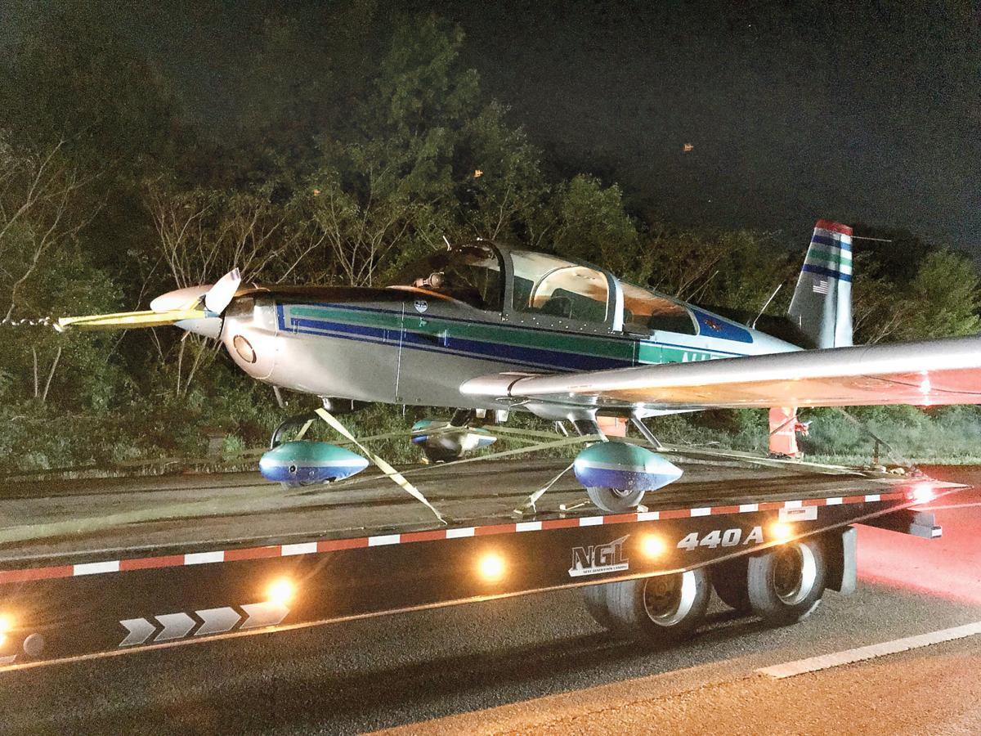It doesn’t usually take 18 law enforcement officers to respond to a disabled three-wheeler on an interstate highway. Then again, not that many three-wheelers are equipped with wings and a prop.
Fortunately the driver, a pilot in this case, managed to keep all wheels between the white lines of Pellissippi Parkway on Sunday evening.
To Blount Countians Greg and Stephanie Gray, it didn’t seem all that out of the ordinary — not at first when they turned off Alcoa Highway shortly after 7:30 p.m. and headed east on Pellissippi toward Old Knoxville Highway. They saw an ambulance and a fire truck and cruisers, but no plane.
“It was wild, because we were just hoping nobody was hurt in an auto accident,” Greg Gray said.
Then Steph Gray spotted the plane. She called her husband’s attention to it and took a photograph as they drove past. He was more worried about maneuvering into the left lane with the rest of the traffic, but saw the small two-seater where it had been moved onto the shoulder.
“As little as it is, you had to be almost on it before you could see it. It almost looked like a toy plane out there, it was so small,” Greg Gray said. “We were immediately trying to figure out, how on earth did that happen?”
Which would have been a natural question for Alcoa Police Officer Kevin Dailey when he was dispatched Sunday evening, as he wrote in his report, “to an airplane that had possibly crashed eastbound on Pellissippi Parkway at Cusick Road with unknown injuries.”
The prospect of tragedy was real. As it turned out, the incident turned out to be more of a “whew!” moment than the disaster it could have been. When he arrived, Dailey found the silver-blue Grumman American AA-5B intact with its wheels safely on the pavement that had served as an emergency runway.
He made contact with pilot Donald Hughes of Avon, Indiana, and his passenger. They had taken off from Indianapolis and were flying to Elberton, Georgia, for a youth ministry when trouble struck. The plane lost oil pressure and Hughes notified the Federal Aviation Administration tower at McGhee Tyson Airport.
Air traffic control granted the pilot priority to land. It might have been just as well for the Tennessee Highway Patrol to have been the authorizing authority. The plane never made it to the runway but did reach the interstate.
“Hughes advised before he could make it to the runway his engine seized up and he did not have enough momentum to land at the airport. He was able to do a controlled landing on Pellissippi Parkway at the Cusick Road exit. Hughes then taxied about three-quarters of a mile and was able to place the plane on the right side of the roadway on the shoulder,” Dailey reported.
A dozen Alcoa Police Department officers responded, along with three Blount County deputies and three safety officers with the Metropolitan Knoxville Airport Authority, including the captain on duty, along with two MKAA Operations staff on the scene and four more assisting on airport property. Alcoa Fire Department and AMR ambulance service also responded.
Through it all, the pilot and passenger appeared composed as officers and emergency personnel surveyed the situation.
Hughes and passenger, Clifford Gardner, “both appeared normal and surprisingly calm,” Dailey reported.
As the Grays drove past, they too noticed the calm.
“Everybody was standing around, almost like everybody was trying to make sense of what happened,” Gray said.
He was thinking about what could have been.
“It was an insane experience I’ve never seen before. Of course I’ve thought for years, just in my mind, how (the planes) cross over Alcoa Highway all the time, the huge ones just coming in to land. Thank goodness it was small. They might have had a little trouble if it was bigger,” Gray said.
“As it is now, it’s kind of funny and something to joke about, but in the moment with the cars coming, I can’t even imagine. It’s some scary stuff.”
The Grumman was loaded onto a flatbed trailer and transported to McGhee Tyson Airport like it had landed, on the road. MKAA spokeswoman Caitlin Darras said the aircraft will be kept at a secure location at TAC Air for inspection.
FAA spokesman Jim Peters said the agency will investigate.

